Installation and operating instructions for CVMsgBuilder v1.4 (distribution date 05/31/2018)

Note: The following instructions apply to PCs running the Windows operating system. These instructions may be adapted to other platforms as required, e.g., MAC.

System requirements

- JRE 7 or later must be installed on the target machine.

Installation

- Store the distribution .zip file in any desired folder.
- Extract the contents of the .zip file.

To run the software:
- Open a command window by running cmd.exe.
- Use cd command to navigate to the distribution folder.
- Type the following:

java -jar dist\CVMsgBuilder.jar

- Diagnostic output is written to the command window. Diagnostic output can be redirected to a file by appending “ > diagout.txt” to the command line. Diagnostic output can be suppressed completely by appending “ > NUL”. Examples follow:

java -jar dist\CVMsgBuilder.jar > diagout.txt
java -jar dist\CVMsgBuilder.jar > NULL

- If the software launched successfully the following will be displayed:

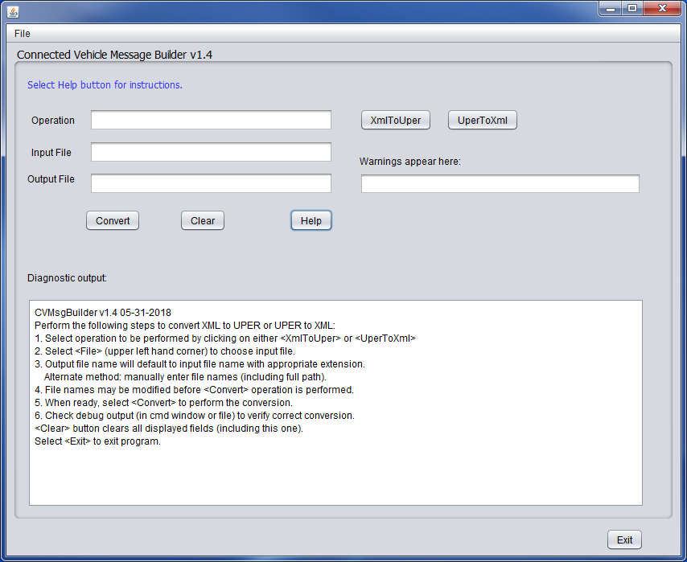
Click on the Help button to see usage instructions displayed in the output area.

Release notes:

10-23-17 v0.1 Initial release. Does not include XML pre-processing functionality (lat-lon to offset conversion).

10-28-17 v0.2 Rebuilt with OSS deployment license. Jar file name changed from “bimv2_xml2uper.jar” to “XmlToUper.jar”.

11-21-17 v0.3 Updated to use new Roadside Safety Message ASN.1 module (rsmv3.asn). Distribution now includes the ASN.1 module (e.g., rsmv3.asn), however this file not required to run the software.

11-27-17 v0.4 Updated to use E-XER decoder (rather than XER decoder used in v0.3). E-XER decoder allows XML style comments to be embedded in the input file’s XML. They are ignored by the decoder, and not included in UPER encoded output.

12-06-17 v0.5 Translates absolute lat/long/elev nodes to offset nodes in Reduced Speed Zone container (only). Constraints for lat/long/elev offsets updated in ASN.1 module rsmv3.asn. Compatible with UperToXml v0.4. Distribution includes the updated ASN.1 module (e.g., rsmv3.asn), however this file not required to run the software.

12-15-17 v1.0 Initial release of Connected Vehicle Message Builder (CVMsgBuilder), a GUI based application which includes the XmlToUper and UperToXml modules. This version supports updated RSM ASN.1 schema rsmv4.1.asn. This release also includes support for the CurveContainer.
Known bugs: The regional extension element added to the CommonContainer does not encode/decode properly. The problem shows up when the following is attempted: a. Convert XML containing the regional extension to UPER, and back to XML. b. Convert resultant XML back to UPER, decode of XML fails. As long as the regional extension is not in the XML, no known issues.

12-27-17 v1.1 Updates include: Support for conversion of absolute nodes to offset nodes in ApproachLane, support for scale factor. Uses updated RSM ASN.1 schema rsmv4.3.asn. (includes changes to ApproachLane and connectsTo). See file rsmv4.3.asn included with this release.

01-21-18 v1.2 Updates include: Generates PDU of type MessageFrame, which encapsulates the RoadsideSafetyMessage. Added lanePosition data element to laneInfo data frame. See file rsmv4.4.asn included with this release.
- IMPORTANT: Note that for applications decoding UPER PDUs generated by this software (v1.2), some updates to the standard J2735 ASN.1 schema must be made to accommodate the RoadsideSafetyMessage. See the file J2735-editing-instructions-RSM.txt for specific details (included in this release).
- Release also includes the sample file “MessageFrame-rsmv4-4-FullExpression.exer”, which represents the “full expression” of possible XML structure available. Note this file does not maximize all possible instances of XML structure (e.g., the file shows two instances of connectsTo while more than two are possible.) The file also does not include regional extensions available in the CommonContainer or in node definitions.

04-24-18 v1.3 Updates include: 1. Supports updated and significantly modified ASN.1 schema. See included file rsmv5.0.asn. 2. Scale is no longer being applied to elevation (i.e., lat/long only). 3. New feature: When converting absolute nodes to offset nodes, determines if distance between nodes would exceed limits of ASN.1 data types for lat/lon, and converts into a segmented node list, i.e., a one-to-many list of offset based nodes. See debug output for diagnostic info displayed to identify when this happens. 4. Also see notes above for v1.2 regarding required J2735 ASN.1 module updates.

05-31-18 v1.4 Updates include: Added message segmentation capability to ASN.1 and software build. See CVMsgBuilder User Guide v1.4 for details. This software release built using ASN.1 file rsmv5.1.asn, included with this release. Cleaned up debug output.

